**M.D.V.M SCHOOL, NEEMRANA**

***HOLIDAY HOME WORK 2019-20***

***CLASS 1***

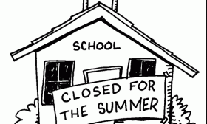

**Name: …………………………………………………………………………………………… Class & Sec: ……………………………………**

M.D.V.M NEEMRANA**HOLIDAY HOMEWORK CLASS 1**

**We hope the children enjoyed their first spell in school as much as we enjoyed getting to know them. The school is a second home. Hope our children have started feeling at home in school by now.**

**Summer Vacations are just round the corner. To keep our little ones indoors in the sweltering heat and to utilize their time with constructive and creative activities, we are sending a few assignments that would help the children get a grasp of the work done in the school.**

**For The Parents**

**Be a Friend** : Play games with your child like–Ludo, Carom-board and puzzle .

**Explore Nature :**Wake your child for morning walk, count trees, cars, stones, flowers,etc. while going for a walk.

**Sharpen Memory :**Put a few things on a tray show the tray to your child for a while and then cover the tray. Ask your child to name the objects which were on the tray. This activity will help enhancing the memory and vocabulary of your child.

**‘Books Can Be Our Best Friends’**

**Reading time :** Reading story books enhances Language and Vocabulary development.

Make bed time reading a regular practice with your child (with pictures and large text). After reading stories ask questions like “Did you like the Story?” “Who was your favourite character in the Story?” etc.

**Suggested Story Book Series:**

|  |  |  |
| --- | --- | --- |
|  |  |  |
| ✓ | Birbal stories |  |

       

|  |  |
| --- | --- |
| ✓ | Ramayana |

     

**Suggested Television Channels :**

* 1. Discovery Kids
  2. National Geographic
  3. Disney Junior

**Suggested Movies to Watch**

* 1. **Jungle book**
  2. Kungfu Panda
  3. Stuart Little
  4. Ramayana The Legend of Prince Rama



M.D.V.M NEEMRANA **HOLIDAY HOMEWORK CLASS 1**

**PERSONALITY DEVELOPMENT**

* **Inculcate following ‘Life skills’ in your child to help Him / Her become independent.**

|  |  |  |  |
| --- | --- | --- | --- |
| • *Buttoning his / her shirt* | | • *Laying the table for dinner* | |
| • | *Tying his / her school Bags* | • | *Arranging shoes in the shoe rack* |
| • | *Packing his / her shoe laces* | • | *Filling the water bottles* |

* + *Keeping his / her belongings back in their place*
* **Imbibe ‘Social Skills’ in your child.**
  + *Greeting with a smile when someone comes to the house*
  + *Conversing feely with visitors, relatives coming over to the house*
  + *Answering the phone calls with a polite “Hello”, also asking “May I know who is calling?”*
  + *Speaking politely and sharing with peers.*
* **Using the magic words**



|  |  |  |  |  |
| --- | --- | --- | --- | --- |
| **I’m** | **Please…** | **Excuse** | **Thank** |  |
| **Sorry** | **Me !** | **You** |  |
|  |  |



**Let’s Converse in English**

* How are You? I’m good/great. Thank You.
* I am thirsty. Please give me Water.
* Please, open / close my tiffin / bottle.
* I am hungry. Please give me food.
* I have finished my work / food
* Please, switch off / on the light / fan.





**May I**



**?**

**PROJECT WORK**

* WIND CHIME
* Make a wind chime by using cut outs of different healthy food items. (using waste material – thread, old CD, wool, cut outs from newspapers and ,magazines and decorative materials)
* NOUN TOWN

Let’s create our NOUN TOWN.

Paste/ draw different pictures of person, things, place or an animal on an A4 size pastel sheet. Name the Noun Town after your own name like Aditi’s Noun Town. The picture can be a hand drawn (coloured), a print out or a cut-out of a magazine. Sample for reference

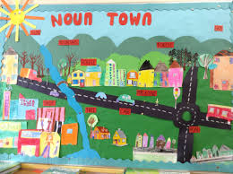

Dear Parent

With the summer reaching its peak, it is time for the kids to be at home and relax. It is a wonderful time to explore, indulge in indoor and outdoor activities and spend valuable quality time with our children. Hope they enjoy cycling, playing with friends, visiting libraries, parks, museums and involving themselves in various activities.

Children look forward to your meaningful engagement with them. The lengthy summer afternoons seem lengthier when the kids are caught indoors however this time can be well utilized by spending time playing board games, word scrabble, Pictionary, reading books with them, playing indoor games, solving puzzles, crosswords and many more.

Parental involvement is important for the success of children. We will appreciate child’s own work. We hope that you have a wonderful time with your child this summer and we thank you for your continued support!

Have a happy, healthy summer vacation!

**Class Teacher**

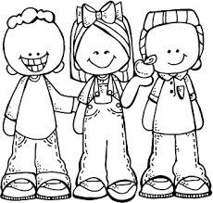

**READING IS FUN**

To enhance their reading skills make your child read stories. Reading books with children helps develop their language skills.

Read to your child every day. Here are some tips to help you. Take your child's age into consideration as you use them.

* Stories that rhyme are very helpful for enhancing language skills and can help children discover a love of language.
* Stories introduce children to things and places they may not have a chance to learn about otherwise, such as oceans or dinosaurs.
* Choose books with colourful pictures that show lots of action and point to the pictures while you read.
* Join your child in reading. Set aside time that you and your child can look forward to and talk about stories, words and ideas.
* It’s not enough to simply use new words during conversation or read them in a book. Children need to learn what words mean and this happens when parents explain what a word means by pointing to pictures, by using their voice or gestures to explain the meaning of the word (for example, using a soft voice when reading “he whispered in her ear…”)

Books can thus open up valuable discussions between a parent and a child.

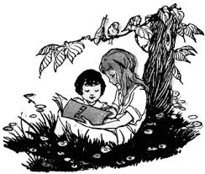

**READING IS FUN!**

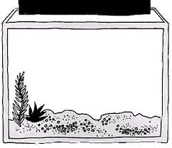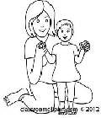**THE SNAIL**

No one knew how the little black snail

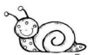got into the fish tank. ‘He’s very small,’

Mother said as she looked at the tiny

snail. ‘Just a black dot.’ ‘He’ll grow,’ said

Nyla and got into her bed. The next morning, Nyla

jumped out of bed and switched on the light

of her fish tank. Golu, the fat orange

goldfish, was sleeping between two stones. Pathli, the angel fish, was

already awake and was swimming along the front of the tank flapping his

white tail. Nyla looked for the snail. It was sticking to the glass near the

bottom. It didn’t move at all.

**THE FROG AND THE BOYS**

A group of boys were near a pond. They picked up some stones and began to throw them into the pond. Stone after stone hit the water. A family of frogs lived in the pond. They were very frightened. Father Frog said to the family, “We’ve got to do something to save ourselves. Let me talk to the boys.’

Father Frog swam to the edge of the pond and said, ‘Please stop throwing stones into the pond. You might hurt us.’ The boys just laughed and continued to throw stones into the pond.

A farmer was watching. He picked up a few small stones. He began to throw them, one at a time, in the direction of the boys.

‘Stop ! Stop! Cried the boys. ‘Can’t you see you may hurt us?’

‘Why should I stop?’ said the farmer. ‘Did you stop when you knew that you might hurt the frogs?’ The boys felt ashamed and walked away.

**Write the new words which you came across in ‘THE SNAIL’**

**and ‘THE FROG AND THE BOYS’ and frame a sentence.**

1. **_____________ _____________________________________________**

**_____________________________________________**

1. **_____________ _____________________________________________**

**_____________________________________________**

1. **_____________ _____________________________________________**

**_____________________________________________**

1. **_____________ _____________________________________________**

**___________________________________________**

1. **_____________ ___________________________________________**

**___________________________________________**

**STORY SEQUENCING**

**Look at the pictures from the story ‘Thirsty Crow’. Write down the numbers in the given boxes in sequence to complete the story. One has been done for you.**

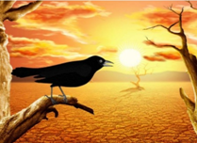

He flew from place to place in search of water.



He went near the jug and looked into it. There was a little water at the bottom of the jug.

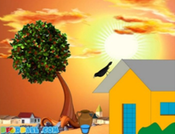

At last, he saw a jug of water near a house.

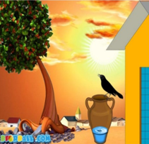

1

It was a hot day. A crow was very thirsty. His mouth was dry.

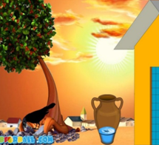

Soon the crow could reach it easily. He drank the water and quenches his thirst.

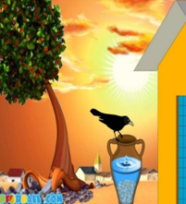

Suddenly, an idea flashed on his mind. He picked up stones one by one.

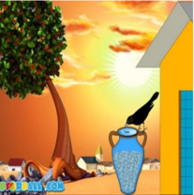

He dropped them into the jug. The water started coming up.

**FATHER’S DAY**

To celebrate the special day with your father one way is to celebrate with the environment. Go to the park with your father on Father’s Day. Click a picture and take a print out of your visit to the park and paste in the space given.

Write 5 sentences on your outing with your father.

|  |
| --- |
|  |
|  |
|  |
|  |
|  |

**MENTAL MATHS**

a. Count the number of blocks and write how many tens and ones are there: 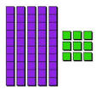 tens and ones

b. Look at the given picture carefully

How many stars are there? ______

Count the stars and group in 2s.

Is the number odd or even? __________

c. Write the numerals of:

one hundred and thirty-_____

four hundred and sixty seven-_____

eight hundred and eleven-______

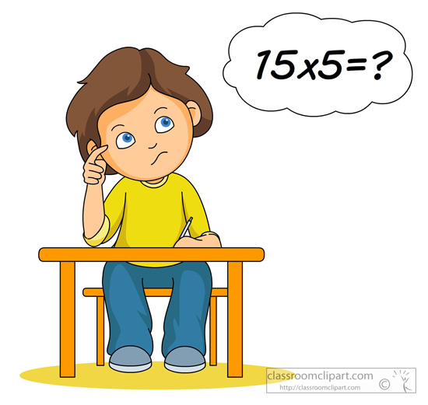d. Write the number names of:

382-__________________________________

699-__________________________________

e. Three fives are =_______

f. Predecessor of 73 is ______

g. Successor of 48 is _______.

h. Three more than 79 is ________

i. Circle the biggest number: j. Circle the smallest number:

Solve the given addition sums to find the message given by your friend.

**A =1, B=2, C=3, D=4, E=5, F=6, G=7, H=8, I=9, J=10, K=11, L=12, M=13, N=14, O=15, P=16, Q=17, R=18, S=19, T=20, U=21, V=22, W=23, X=24, Y=25, Z =26**

**1 2**

1. **1+1=____ 4+1=____ 6+6=____ 5+4=_____ 4+1=____ 10+12=_____ 2+3=_____**

**Word: ________ __________ __________ ___________ ___________ ____________ _________**

1. **5+4=____ 7+7=____**

**Word: ________ ________**

1. **10+10=___ 4+4=___ 4+1=___**

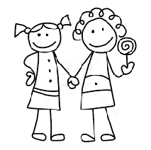**Word: _________ _______ _______**

1. **6+7=___ 1+0=___ 6+1=___ 6+3=___ 2+1=___**

**Word: _______ _______ _______ ______ ______**

1. **7+8=___ 2+4=____**

**Word: _______ _______**

1. **5+1=__ 9+9=___5+4=___ 3+2=___9+5=___3+1=___15+4=___4+4=__6+3=__8+8=___**

**Word: _____ ______ ______ _____ ______ ______ ______ _____ _____ _____**

**Write the message here ___________________________________**

**Star Maths- Do pages 26 to 30, 36,38,39,40,41 and 46.**

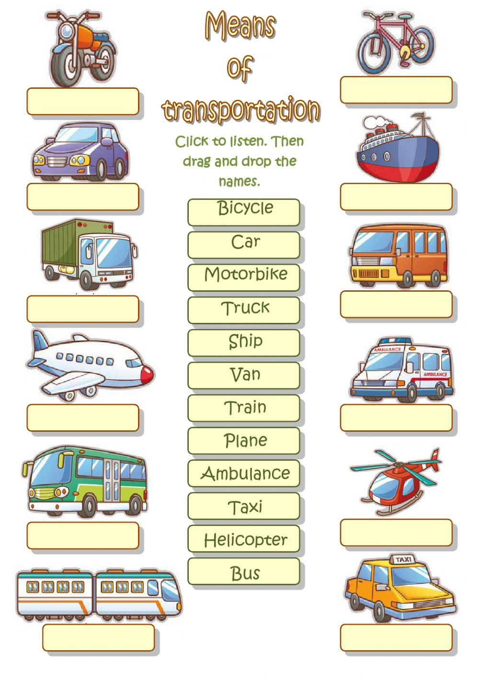

**बारहखड़ी प से म तक लिखे ---**

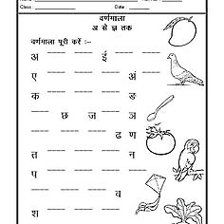

**Periodic test – 1 ( Syllabus)**

|  |  |
| --- | --- |
| **English** | Unit 1 and 2 ( New words and Question/ Answers) |
| **Grammar**- Noun and One/many |
| Five lines on ‘ Myself’ |
|  | |
| **Hindi** | हिंदी - पाठ - 1 ,2, बारहखड़ी,स्वर ,व्यंजन याद करें | |
|  | |
| **Maths** | Star Maths Chapter – Numbers |
| Tables 2 to 5 |
|  | |
| **Computer** | Chapter 1 ( Hello Computer) with exercises. |
|  | |
| **Mindfulness** | Lesson -1 Myself and lesson-2 My food habits ( All the work done in notebook) |

* **Note- All the work done in notebooks in all the subjects will be included.**